Dumbrell, Ian (from Linked In)
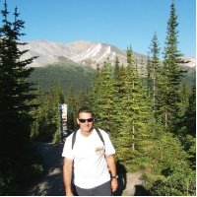

Applecross Senior High School Leaving Certificate 1970 –74.

Murdoch University Bachelor of Science (Honours), Environmental Science/Biology, Honours 1982 – 1994. Forester Dept CALM February 1984 – February 1994 Busselton. Biological Research Scientist at CALMScience Busselton in 1999. Research Scientist Dept CALM February 1994 – February 2004 Busselton. Challenger Institute of Technology Diploma, Human Resources Management, 2001 – 02. Senior Research Scientist Forest Products Commission, WA February 2004 – July 2010 Bunbury. Manager Forest Science and Industry Development Dept Agriculture and Food WA August 2010 – June 2013 Bunbury. Central Institute of Technology, Western Australia Diploma, Project Management 2012. July 2013 – Forest Products Commission Bunbury WA.

Interests
  - Surfing,
  - Travel,
  - Fishing,
  - Australian History

